

charting the course of innovation: A startup Analysis

Project Flow



[Date]

[Company name]

[Company address]

**Introduction**

* 1. **Overview**

The startup industries has expanded rapidly, with more companies emerging in various sector. According to Inc., there were 30 million small business in the United States alone in 2019, and approximately 627,000 new businesses were established yearly. Furthermore the COVID-19 pandemic hastened the industries growth, with more people turning to online services and companies. As a result, the industries is expected to expand further, with new opportunities to emerging in the healthcare, education and finance sectors.

* 1. **Purpose**

A startup analysis is essential to the success of any startup business. It allows entrepreneurs to identify the key areas that need improvement and make necessary changes early on. Doing a startup analysis also allows startups to track their progress and ensure that they are on track to achieve their goals.

**2. Problem Definition and Design Thinking**

**2.1 Empathy Map**

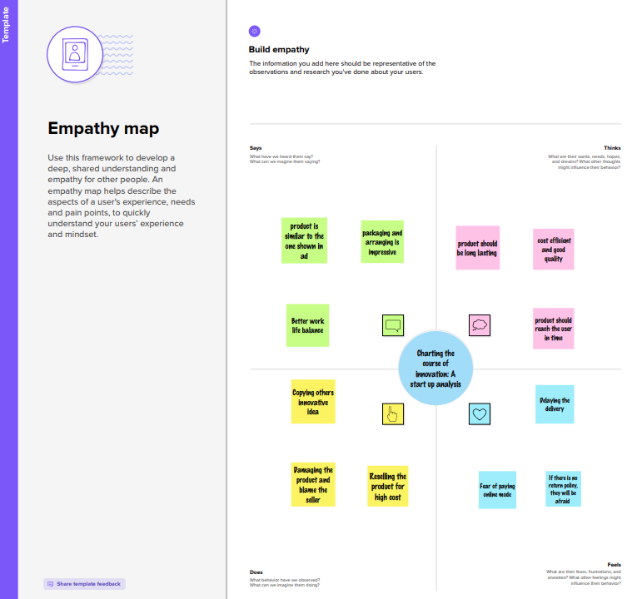

**2.2 Ideation & Brainstorming map**

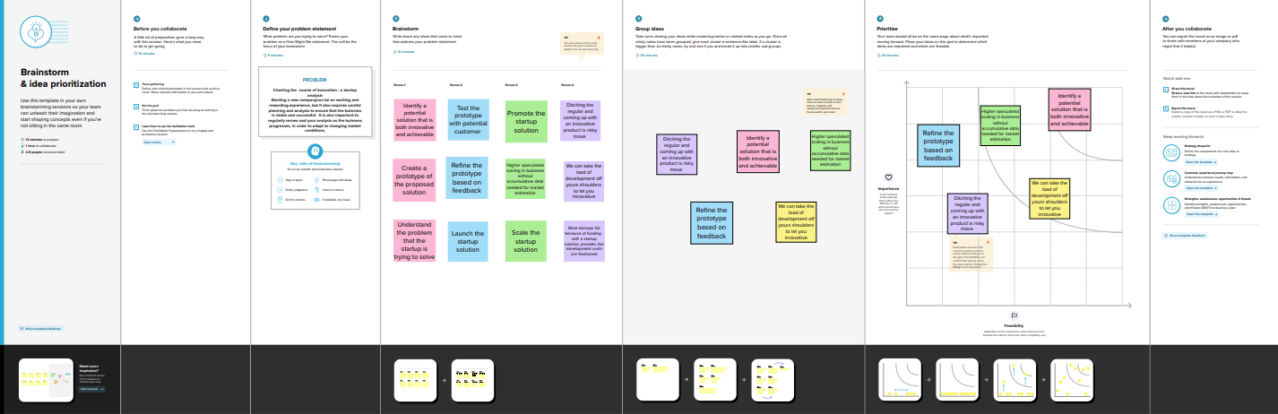

**3.Result**

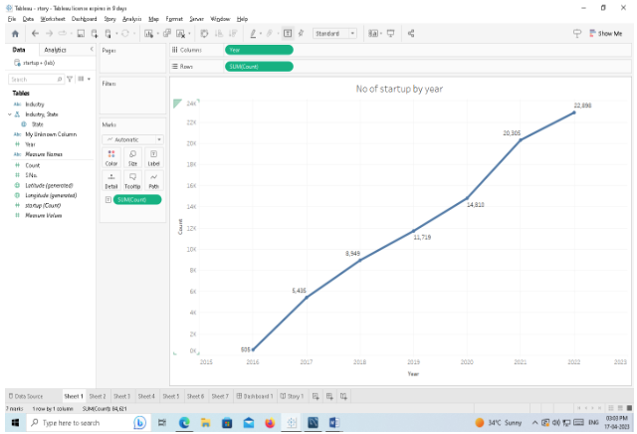

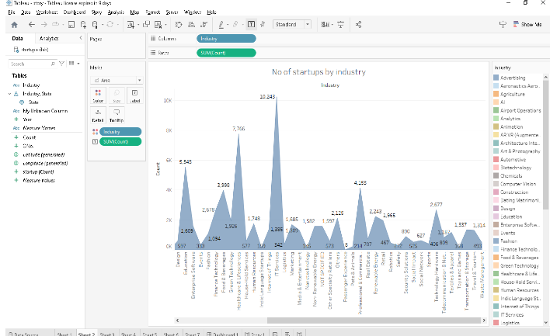

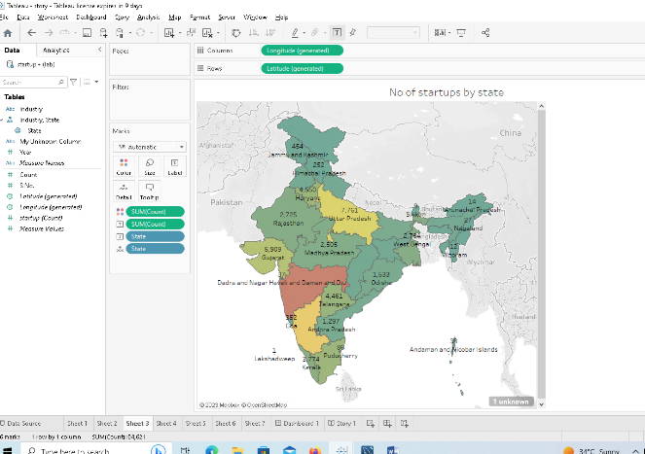

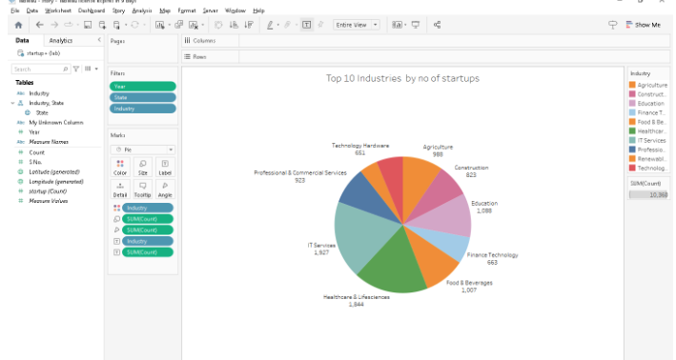

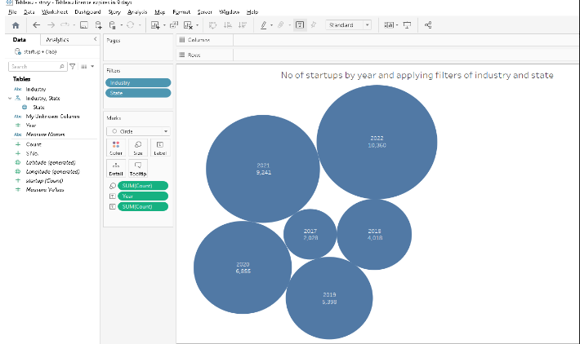

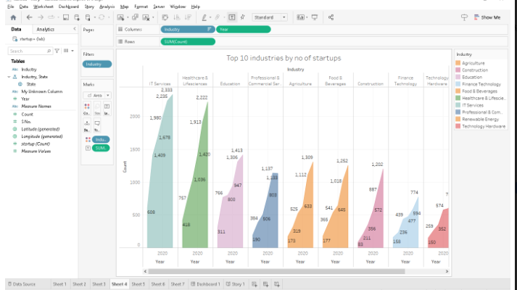

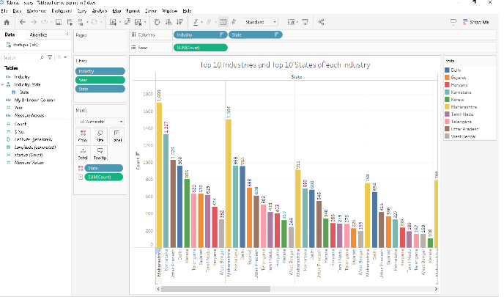

**4.Advantages & Disadvantages**

**Advantages**

* More opportunities to learn
* Flexible hours
* Unique Experiences
* Lots of workplace benefits
* Increased job satisfaction
* Minimal supervision
* Opportunities for innovation

**Disadvantages**

* Uncertain job security
* A heavy work load
* Long hairs
* Less pay
* Lack of structure
* Constant change
* Limited Resources
* To much Freedom

**5.Application**

* This analysis will help you identify trends and patterns in your company’s financial data.
* It will also help you indentify areas of improvement and make decisions about your company’s future.
* A startup analysis can be valuable tool for early stage companies.

**6.Conclusion**

Startup-friendly policies in India do not always necessitate large sums of money or incentives.They do,however,need help from successful founders and strategic angels in all stages of development,such as business strategy,community building,and connecting with skilled business mentors.As India has a massive,diverse population with many talented individuals in search of work,It is essential to develop state ecosystem by establishing a startup policy,startup portal and helpline within every state.Creating incubation centers,co-working spaces,entrepreneurial cells, and instilling and entrepreneurial spirit in every student at a young age is even more necessary.

**Dashboard**

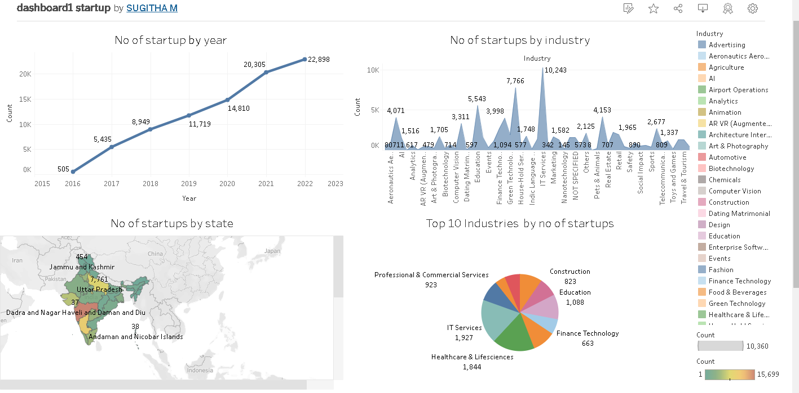

**Story**

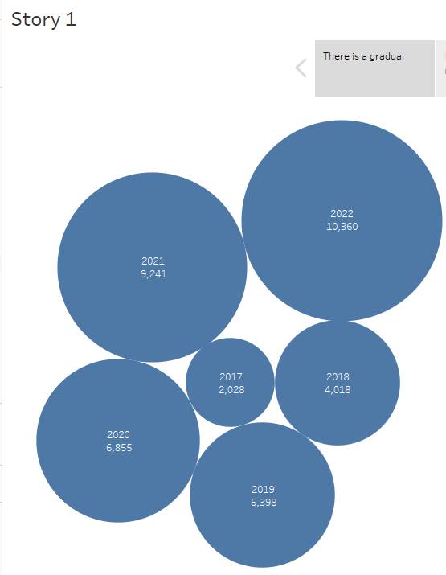

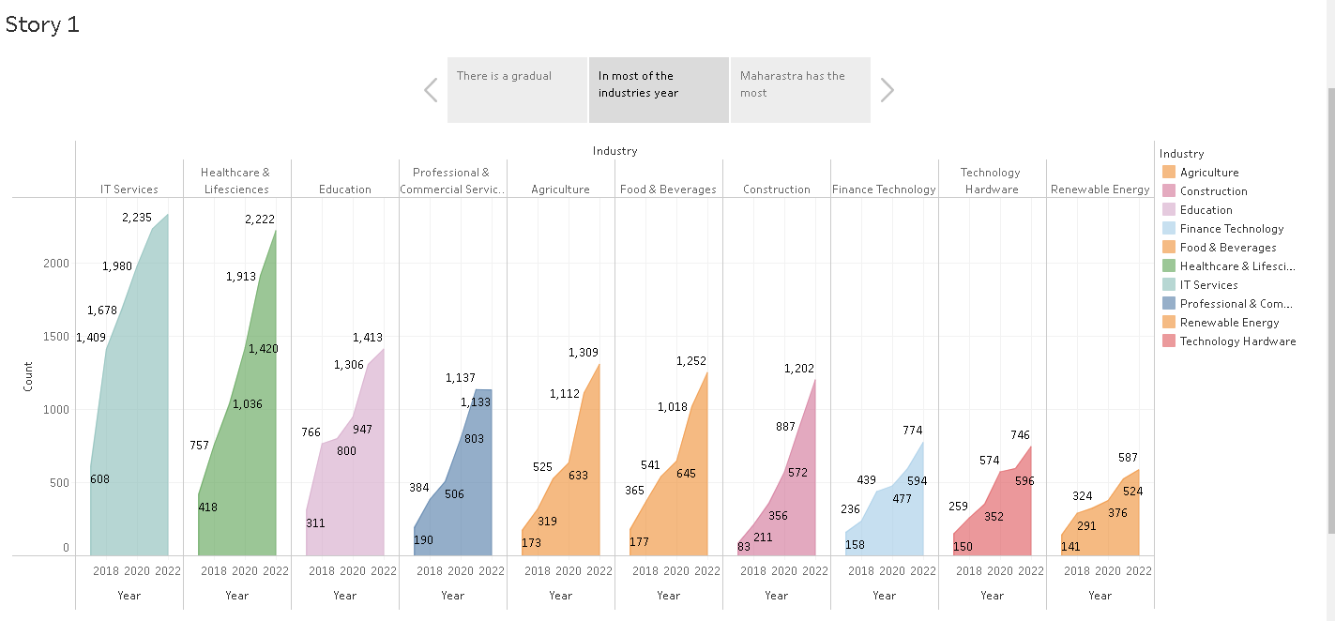

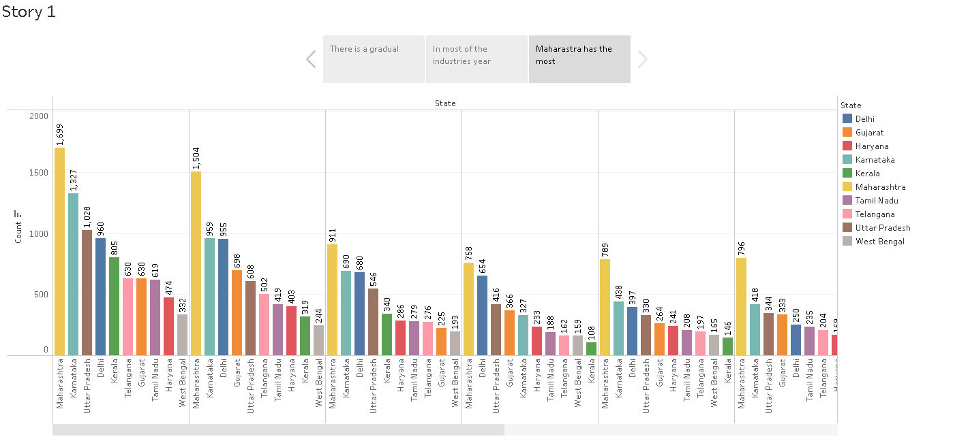

**7.Future scope**

India can be considered a youthful country as it has been 65 years of its Independence. The population growth and shortage of skilled workers have been the two main variables influencing the employment market situation nowadays. These days, businesses are searching for experts that are qualified and can provide outcomes for the individuals who desire to pursue independent company. Below is the 3 primary scope of Start-Up Companies in Modern India.

* **Increase in Globalization**

A lot of factors, including globalization and the rise of the IT industry were majorly responsible for the rise of entrepreneurship in India. Higher pay scales with good designations offered by several private sectors or multinational companies encouraged the people.

* **Startup Ecosystem**

The startup ecosystem is receiving a lot of support from international and Indian investors, who have increased trust in the sector and have committed funding to enable these businesses to develop. Today, the Indian economy is undergoing an immense makeover with new strategies rolling into the market emphasizing and enhancing the role and contribution of startups.

* **Make In India initiative**

The government of India launched the “Make in India” project to encourage businesses to create, produce, and assemble goods in India and to encourage targeted investments in manufacturing. The goal of the strategy was to create a business-friendly atmosphere, buildup an effective infrastructure, and open up new markets to foreign investment.

**8.Appendix**

* **Source code**
  + **Dashboard**

<div class='tableauPlaceholder' id='viz1681971926993' style='position: relative'><noscript><a href='#'><img alt='Dashboard 1 ' src='https:&#47;&#47;public.tableau.com&#47;static&#47;images&#47;da&#47;dashboard1startup&#47;Dashboard1&#47;1_rss.png' style='border: none' /></a></noscript><object class='tableauViz' style='display:none;'><param name='host_url' value='https%3A%2F%2Fpublic.tableau.com%2F' /> <param name='embed_code_version' value='3' /> <param name='site_root' value='' /><param name='name' value='dashboard1startup&#47;Dashboard1' /><param name='tabs' value='no' /><param name='toolbar' value='yes' /><param name='static_image' value='https:&#47;&#47;public.tableau.com&#47;static&#47;images&#47;da&#47;dashboard1startup&#47;Dashboard1&#47;1.png' /> <param name='animate_transition' value='yes' /><param name='display_static_image' value='yes' /><param name='display_spinner' value='yes' /><param name='display_overlay' value='yes' /><param name='display_count' value='yes' /><param name='language' value='en-US' /></object></div> <script type='text/javascript'> var divElement = document.getElementById('viz1681971926993'); var vizElement = divElement.getElementsByTagName('object')[0]; if ( divElement.offsetWidth > 800 ) { vizElement.style.width='100%';vizElement.style.height=(divElement.offsetWidth*0.75)+'px';} else if ( divElement.offsetWidth > 500 ) { vizElement.style.width='100%';vizElement.style.height=(divElement.offsetWidth*0.75)+'px';} else { vizElement.style.width='100%';vizElement.style.height='1427px';} var scriptElement = document.createElement('script'); scriptElement.src = 'https://public.tableau.com/javascripts/api/viz_v1.js'; vizElement.parentNode.insertBefore(scriptElement, vizElement); </script>

* **Story**

<div class='tableauPlaceholder' id='viz1681972069500' style='position: relative'><noscript><a href='#'><img alt='Story 1 ' src='https:&#47;&#47;public.tableau.com&#47;static&#47;images&#47;st&#47;story1startup&#47;Story1&#47;1_rss.png' style='border: none' /></a></noscript><object class='tableauViz' style='display:none;'><param name='host_url' value='https%3A%2F%2Fpublic.tableau.com%2F' /> <param name='embed_code_version' value='3' /> <param name='site_root' value='' /><param name='nam**e'** value='story1startup&#47;Story1' /><param name='tabs' value='no' /><param name='toolbar' value='yes' /><param name='static_image' value='https:&#47;&#47;public.tableau.com&#47;static&#47;images&#47;st&#47;story1startup&#47;Story1&#47;1.png' /> <param name='animate_transition' value='yes' /><param name='display_static_image' value='yes' /><param name='display_spinner' value='yes' /><param name='display_overlay' value='yes' /><param name='display_count' value='yes' /><param name='language' value='en-US' /></object></div> <script type='text/javascript'> var divElement = document.getElementById('viz1681972069500'); var vizElement = divElement.getElementsByTagName('object')[0]; vizElement.style.width='100%';vizElement.style.height=(divElement.offsetWidth*0.75)+'px'; var scriptElement = document.createElement('script'); scriptElement.src = 'https://public.tableau.com/javascripts/api/viz_v1.js'; vizElement.parentNode.insertBefore(scriptElement, vizElement); </script>